**Foodee Restaurant Ordering System**

Contents

**1.** **Admin Screen** 3

**2.** **Customer Screen** 4

**3.** **Chef Application** 5

**4.** **Mock - up screens:** 7

# **Admin Screen**

* 1. **Initiating Actor**

System administrator

* 1. **Description**

Content management system should be accessed by the administrator to list/create/edit/delete dishes comprising of description, image, and price and cooking duration.

* 1. **Pre-Condition**

System administrator should be successfully login in to the system.

* 1. **Post-Condition**

System administration should list/create/edit/delete dishes comprising of description, image, price and cooking duration.

* 1. **Basic Flow of Events**

|  |  |  |  |
| --- | --- | --- | --- |
| Step # | Actor Action | Validation | System Action |
| 1 | On successful login |  | System should display the below options for the user selection.   * Create dishes * Edit dishes * Delete dishes * View dishes |
| 2 | Actor selects Create dishes option |  | System should display the screen with below fields for the actor to key in the details with Create and Cancel buttons.   * Item Name * Duration * Price * Currency * Image * Additional Information |
|  | Actor click Add Dish button | All the fields should be mandatory. If any of the details are not provided, system to prompt the message or highlight the fields to key in the details | System should list the newly created dish under View dishes option |
| 3 | Actor selects Edit dishes option |  | System should display the screen showing the created list of the dishes.  On selection of any of the listed dishes, the system should display the below fields by retrieving the below field data from the database with Save and Cancel button.   * Item Name * Duration * Price * Currency * Image * Additional Information   Note: Save button should be enabled only when any of the data is modified. |
|  | Actor click Save button after modification of the data | Save button should be enabled only when any of the data is modified. | System should save the dish details as per the modification of the user.  Modified details of the dish should be reflected under the List dishes |
| 4 | Actor selects Delete dishes option |  | Admin to select the Ref Id for the dish from the View Dishes section and key in to the ‘Reference No’ field. |
|  | Actor clicks on the Delete button | System should prompt message when user clicks Delete button without giving the ‘Reference No’. | System should delete the dish details from the database.  Deleted dishes should not be displayed under List dishes option |
| 5 | Actor selects List dishes option |  | System should display the screen with the list of dishes.  Description, Image, Price and Cooking duration details of the dishes should be displayed. |

# **Customer Screen**

* 1. **Initiating Actor**

Customer

* 1. **Description**

Customer to submit an order of dishes mentioning the number the portions to be cooked under the Customer screen.

* 1. **Pre-Condition**

Customer should be able to view the list of dishes available in the system.

* 1. **Post-Condition**

Customer should be able to place an order

* 1. **Basic Flow of Events**

|  |  |  |  |
| --- | --- | --- | --- |
| Step # | Actor Action | Validation | System Action |
| 1 | Actor to provide the Quantity of each dish from the listed dishes. |  | System should display the list of dishes with Quantity field across each dish and table no field to be displayed. |
| 2 | Actor click Reset button |  | System to clear all the quantity fields for the dishes. |
| 3 | Actor click Show Summary button | Actor to provide the quantity for at least for one item and should provide the Table no. | System to display the selected list of dishes in table   * S. No * Name * Quantity * Duration (min) * Price ($)   System to provide the 2 Buttons for ‘Go Back’ and ‘Confirm Order’ |
| 4 | Actor clicks ‘Go Back’ button |  | System to take back user to the previous screen to modify the portions. |
| 5 | Actor clicks ‘Confirm Order’ button |  | System to provide the confirmation for the Order received. |

# **Chef Application**

* 1. **Initiating Actor**

Chef

* 1. **Description**

The dishes selected by the customer to be grouped and forwarded to chefs by the system.

At any point of time one Chef can take only dish at a time with multiple portions.

Whenever a chef finish cooking a dish, the chef would click to see what should be his next dish.

* 1. **Pre-Condition**

Chef should be successfully login in to the system.

* 1. **Post-Condition**

Chef should get the dish to be cooked

* 1. **Basic Flow of Events**

|  |  |  |  |
| --- | --- | --- | --- |
| Step # | Actor Action | Validation | System Action |
| 1 | On successful login | At any point of time one Chef can take only dish at a time with multiple portions. | System should display the list of dishes pending for a chef to be finished (dishes chosen by the chef should have Finish button).  System should display the list of Next job list for the Chef with start button.  Dishes which are finished will not appear in the job list. |

# **Mock - up screens:**

* 1. **Home screen:**

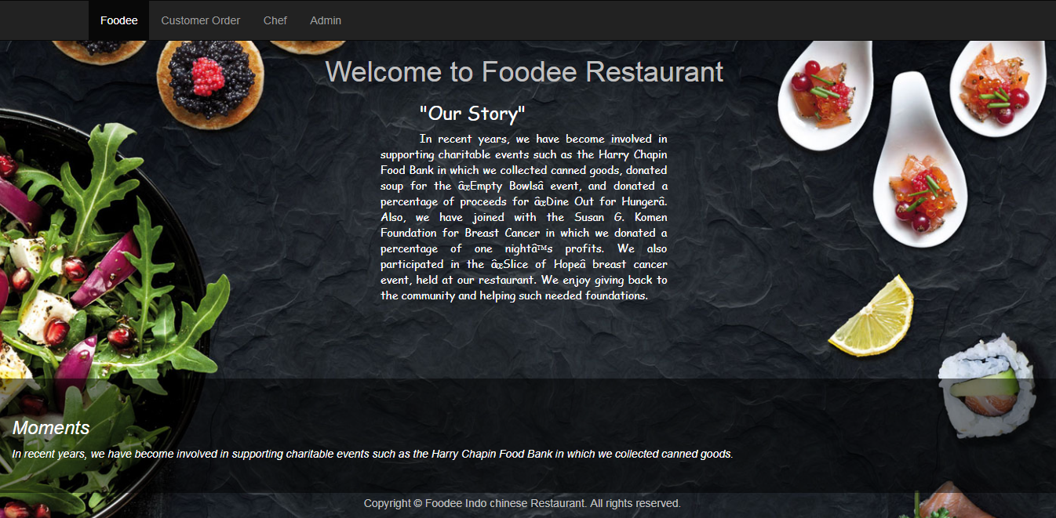

* 1. **Sign in Page for Chef and Admin**

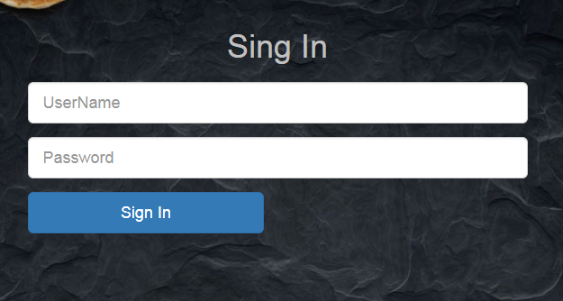

* 1. **Admin – View Dishes**

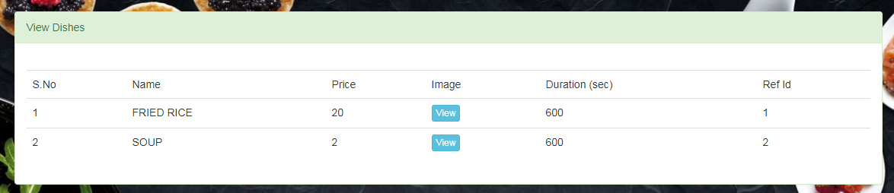

* 1. **Admin – Create Dishes**

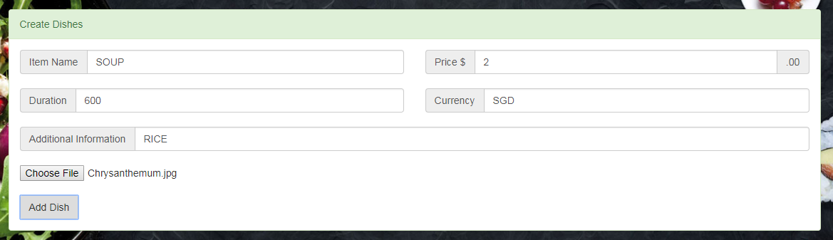

* 1. **Admin – Delete Dishes**

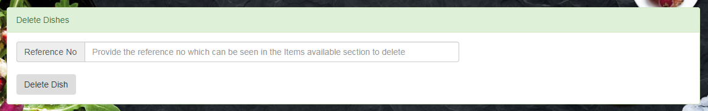

* 1. **Admin – User creation**

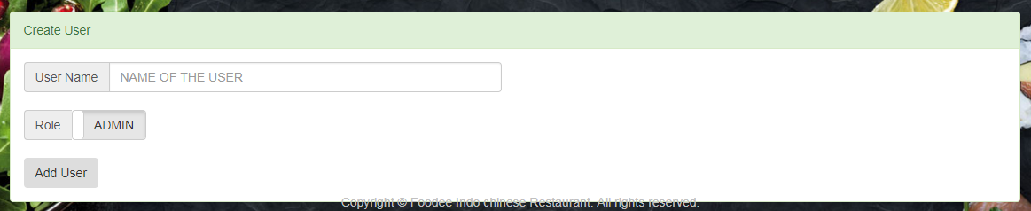

* 1. **Customer – Order menu**

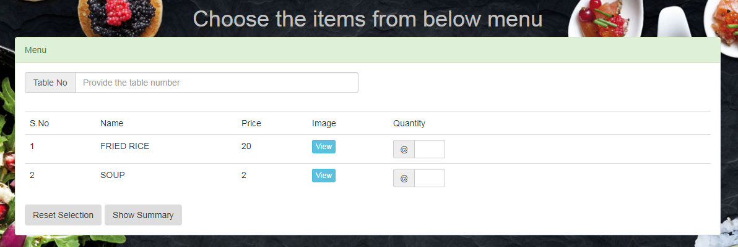

* 1. **Customer – Summary screen**

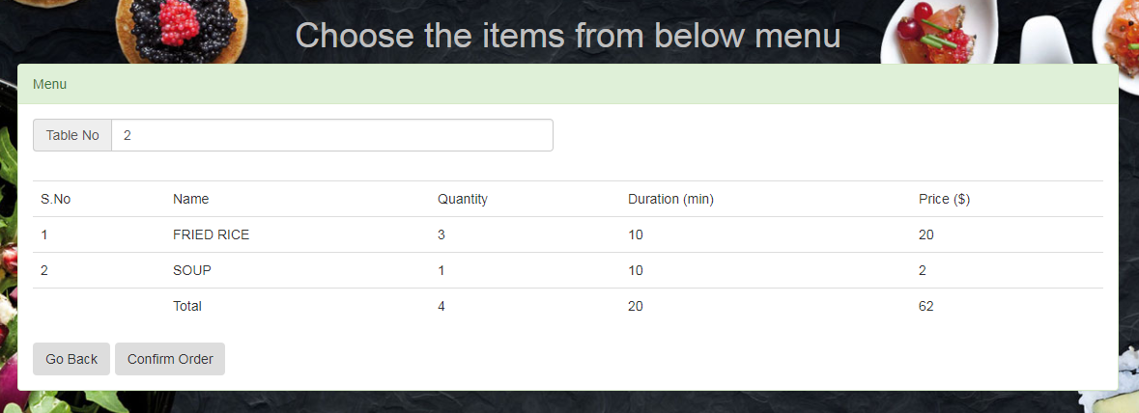

* 1. **Customer – Confirmation screen**

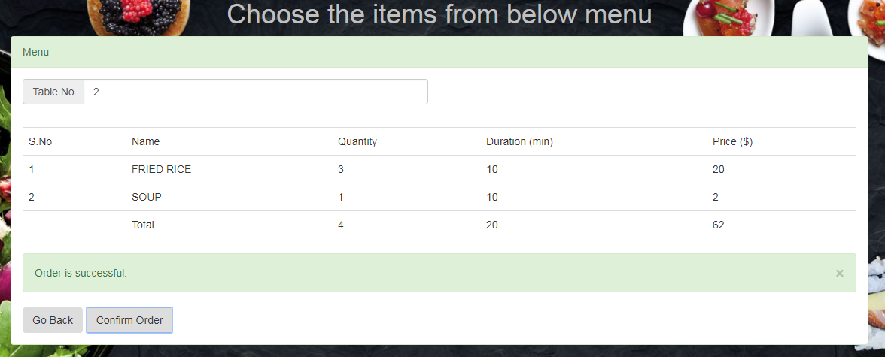

* 1. **Chef – User screen 1**

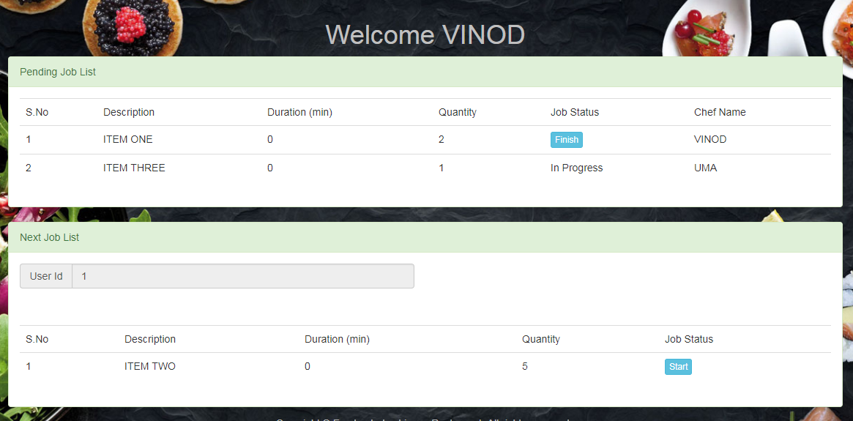

* 1. **Chef – User screen 2**

